Your Wedding Menu Selector…

For the perfect day you, of course, want the perfect meal before dancing the night away. Please take a look at our following menus and see what takes your fancy. We aim to cater to any preferences, whether personal or medical, if possible.

Happy Selecting!

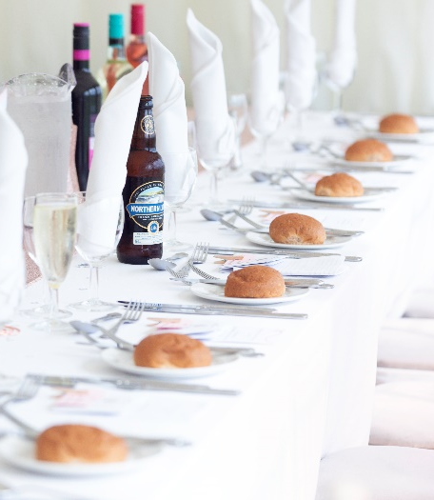
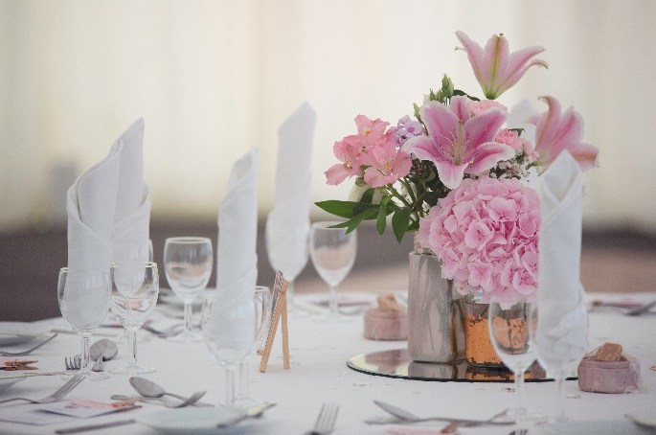

Canapés
Mini Haggis Bon Bons with a Mustard Dip

Mackerel Pate

Melon and Parma Ham

Scrambled Egg and Smoked Salmon

Chicken Liver Pate

Prawn Marie Rose

Salmon & Crème Fraiche

Smoked Salmon with Crowdie

Mini Jacket Potato with Crème Fraiche and Chive

Sun Dried Tomato, Mozzarella and Pesto

£1.25 per canapé per person
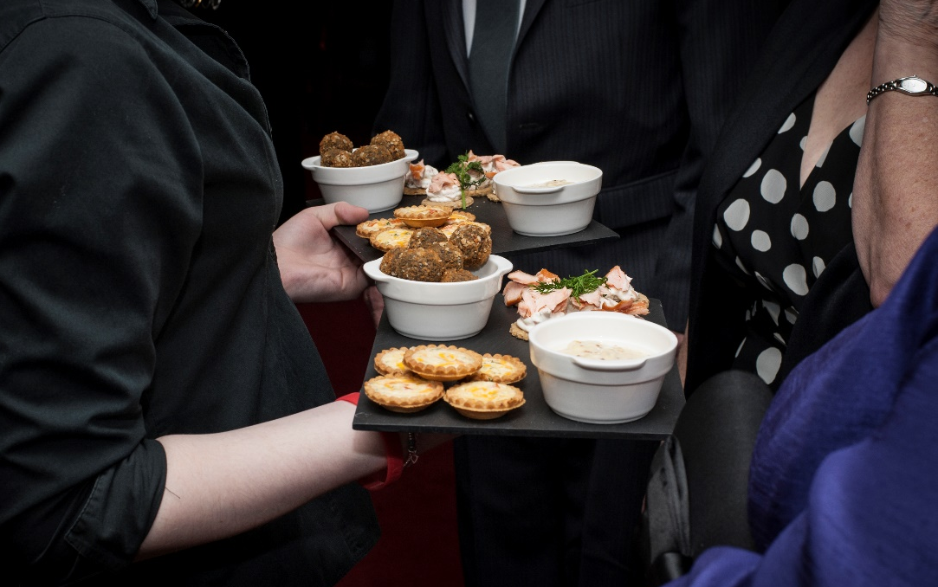
We recommend 2-4 canapés per person, they can be served before your meal.
Menu A
Starters

Couple’s Choice of Soup with Local Bakery Granary Bread

Chicken Liver Parfait with Red Onion Marmalade and Oatcakes

Fan of Honeydew Melon with Wild Berry Compote (vegan)

Saladette of Prawns with Marie Rose Sauce

Haggis Filo Basket with Honey and Mustard Sauce

Main Course

Roast Silverside of Caithness Beef
Served with Yorkshire Pudding

Grampian Chicken
Served with a Whisky and Onion Sauce

Baked Salmon
Served with a White Wine and Chive Sauce

Steak and Norseman Ale Pie

Roast Loin of Pork
Served with a Sage and Cider Jus

All of the above would be served with Roast Potatoes, Dauphinoise Potatoes and Seasonal Vegetables

Pentland Salad
Choice from either Chicken, Honey Roast Ham, Prawn or Poached Salmon

£29.50 PER PERSON
Menu B
Starters

Couple’s choice of Soup with Local Bakery Granary Bread

Scrabster Crab Tartlet with Lemon and Dill Crème Fraiche

Fan of Galia Melon with Parma Ham and Pineapple Salsa

Ham Hock Terrine with Tomato Chutney and Oatcakes

Smoked Salmon and Prawn Salad with Horseradish Cream

Main Course

Roast Sirloin of Beef
Served with Yorkshire Pudding

Venison Casserole

Breast of Chicken
Served with Spring Onion Mash and a Wild Mushroom Sauce

Baked Sea Bass
Served with Artichoke Puree and a Red Wine Jus

Roast Leg of Lamb
Served with a Honey and Cider Reduction

All of the above would be served with Roast Potatoes, Dauphinoise Potatoes and Seasonal Vegetables

Pentland Salad
Choice from either Chicken, Honey Roast Ham, Prawn or Poached Salmon

£32.50 PER PERSON
Carvery Style
Starters
Couple’s Choice of Soup served with Local Bakery Granary Bread
Homemade Chicken Liver Parfait with Red Onion Marmalade and Oatcakes
Fan of Honeydew Melon with Wild Berry Compote
Saladette of Prawns with Marie Rose Sauce
Smoked Chicken and Mushroom Terrine with Beetroot Chutney

Main Course
Roast Beef, Loin of Pork, Roast Turkey, Honey Roast Gammon and Roast Lamb all served from our Carvery with a wide range of potatoes and vegetables including Dauphinoise Potatoes, Roast Potatoes, Red Cabbage and Roasted Parsnips.

£29.50 PER PERSON

Children’s Menu
Margherita Pizza
Creamy Macaroni
Turkey Dinosaurs
Chicken Fillets
Mini Pentland Burger
Sizzling Sausages
Mini Pentland Salad – Beef, Chicken or Cheese

All of the above served with a choice of chips or mash potatoes and beans, peas or salad
Vegetarian & Vegan Options
Starters
Couple’s Choice of Soup served with Local Bakery Granary Bread
Caprese Salad with Balsamic Vinegar*
Vegetable Spring Rolls with Sweet Chilli Sauce
Bruschetta Topped with Tomato, Pesto and Parmesan*

Main Course
Chickpea, Sweet Potato and Spinach Curry*
Served with basmati rice
Wild Mushroom and Butternut Squash Stroganoff
Served with basmati rice
Vegetable Strudel*
Served with a Tomato and Basil Sauce
Spinach and Ricotta Tortellini
Served with Garlic Bread

Dessert
Chocolate Fudge Cake*
Selection of Sorbets
Fresh Fruit Salad
Chocolate Brownie Sundae*
Apple and Blackberry Crumble*

*Can be made vegan upon request

Soup Options
Scotch Broth
Cock a Leekie (GF)
Lentil (GF)
Broccoli and Stilton (GF)
Roasted Red Pepper and Tomato* (GF)
Courgette and Brie (GF)
Green Pea and Smoked Ham (GF)
Sweet Potato and Coconut* (GF)
Cream of Wild Mushroom* (GF)
Carrot and Coriander* (GF)
*can be made vegan upon request

Dessert Options

Orkney Fudge and Old Pulteney Cheesecake*
Limoncello and Raspberry Cheesecake*
Mango & White Chocolate Brûlée*
Individual Lemon Meringue Pie
Chocolate Profiteroles
Glazed Lemon Tart with Raspberry Coulis and Chantilly Cream
Pavlova with wild Scottish Berries
Sticky Toffee Pudding
White Chocolate and Raspberry Brûlée*
Warm Chocolate Fudge Cake
Fresh Fruit Salad Selection of Ice Creams

Cheeseboard Platter £20 per table

*Cheesecake and Brûlée can be made to any flavour of the Bride & Grooms Choice

Evening Buffet
We offer various options for your evening buffet that get served by our staff. We usually serve evening buffets anytime between 10pm-10.30pm after the evening guests have worked up an appetite after dancing away.

Option 1 - Selection of Sandwiches, Sausage Rolls, Tea and Coffee
£6.50
Option 2 - Soup, Selection of Sandwiches, Tea and Coffee
£7.25
Option 3 - Stovies, Selection of Sandwiches, Tea and Coffee
£9.25
Option 4 – Soup, Hot filled rolls (bacon, sausage and fried egg), Tea and Coffee.
£11.50
Option 5 – “Finger Buffet” Selection of Sandwiches, Sausage Rolls, Pizza, Chicken Wings, Spring Rolls, Mini Pies, Mini Quiche, Tea and Coffee.
£14.50
Option 6 – “Pentland Chip Shop” Fish and Chip Cone, Burger and Chips, Mine Pie and Chips, Macaroni Pie and Chips, Tea and Coffee.
£15.50

Drinks Packages
We offer different packages for drinks that can be altered to include specific drinks that you may like.

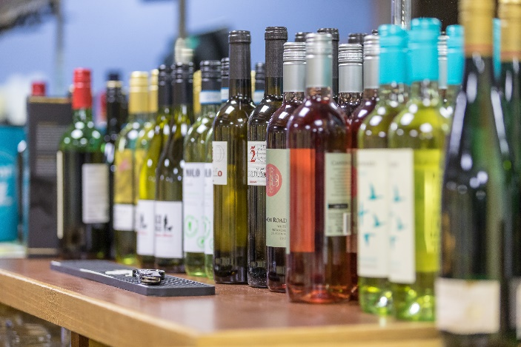
Drinks Package A
Arrival - Any drink or glass of wine
With Meal – Glass of Wine
Toast – Guests Choice
£12.50 per person

Drinks Package B
Arrival - Any drink or glass of wine
With Meal – 2 Glasses of Wine
Toast – Guests Choice
£15.00 per person

Drinks Package C
Arrival – Glass of Prosecco or Bottled Beer
With Meal – Glass of Wine
Toast – Glass of Prosecco
£13.50 per person

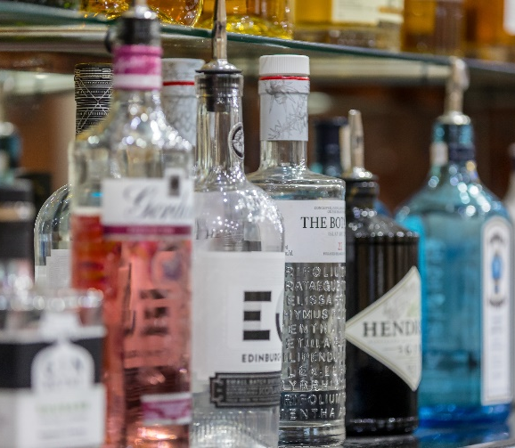
Drinks Package D
Arrival – Glass of Prosecco or Bottled Beer
With Meal – 2 Glasses of Wine
Toast – Glass of Prosecco
£16.00 per person
Menu Selections
Bride’s Name: ________________ Groom’s Name: _______________
Wedding Date:___________

Please circle the menu option you would like.

Menu ‘A’ | Menu ‘B’
Starter Options
We suggest at least 3 options
Main Course Options
We suggest at least 3 options
Trio of Desserts | YES NO
If yes please state which option you’d like.
If no please fill in the below
Dessert options
We suggest at least 3 options
Evening Buffet | YES NO
If yes please state which option you’d like.
Drinks Package | A B C D

