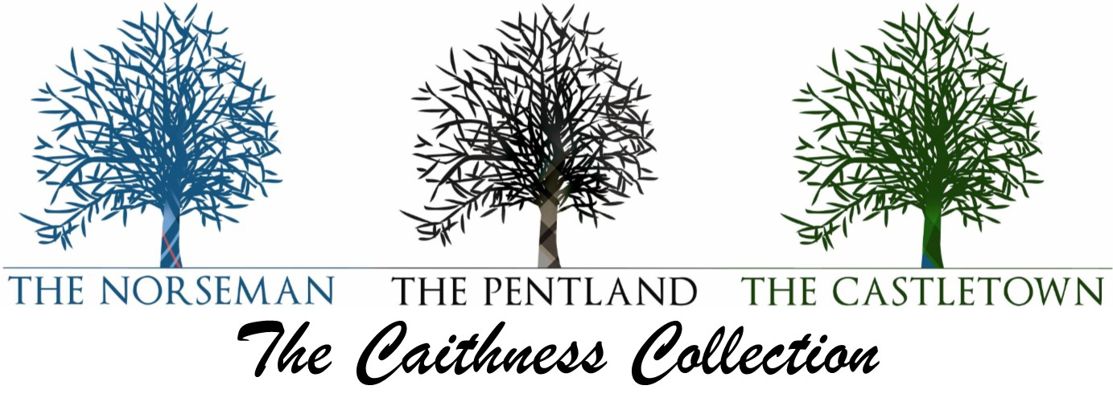
PENTLAND HOTEL TAKEAWAY MENU
PLEASE CALL 01847 893202 TO ORDER

Starters
Soup Of The Day £4.95
Prawn Cocktail £7.95
Haggis, Neeps & Tatties £6.95
Haggis Bon Bons served with Neeps, Mashed Potatoes & a honey mustard Sauce

Mains
Beer Battered or Breaded Chicken Fillets £12.75
Served with Hand Cut Chips
Beer Battered or Breaded Haddock £13.95
Served with Hand Cut Chips & Peas
Cajun Chicken Burger £13.45
Served with sweet chilli mayonnaise and Sweet Potato Fries
Cheese and Bacon Burger £13.95
Served with Hand Cut Chips
Venison and Red Currant Sausages £13.95
Served with Mashed Potato and an Onion Gravy
Grilled Salmon £16.95
Served with Savoy Cabbage and a Honey Mustard Sauce
Carbonara £11.95
Choice of Penne, Linguini or Spaghetti, Served with Garlic Bread
Macaroni Cheese £11.95
Served with Hand Cut Chips and Garlic Bread
Lasagne £12.95
Served with Hand Cut Chips and Garlic Bread

Sweets
Cheesecake of The Day £4.95
Banoffee Pie £5.95
Sherry Trifle £3.95
Hot Chocolate Fudge Pudding £5.95
Sticky Toffee Pudding £5.95

